Sorting Algorithms

- Merge Sort

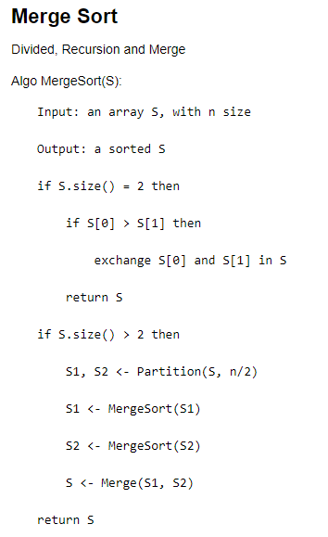

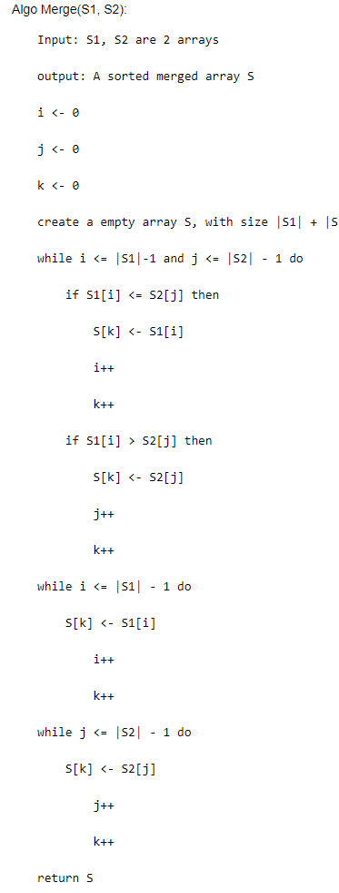

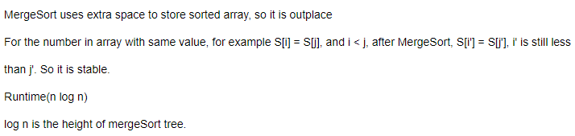

- Quick Sort

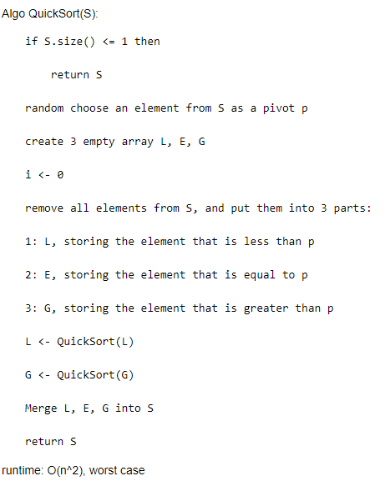

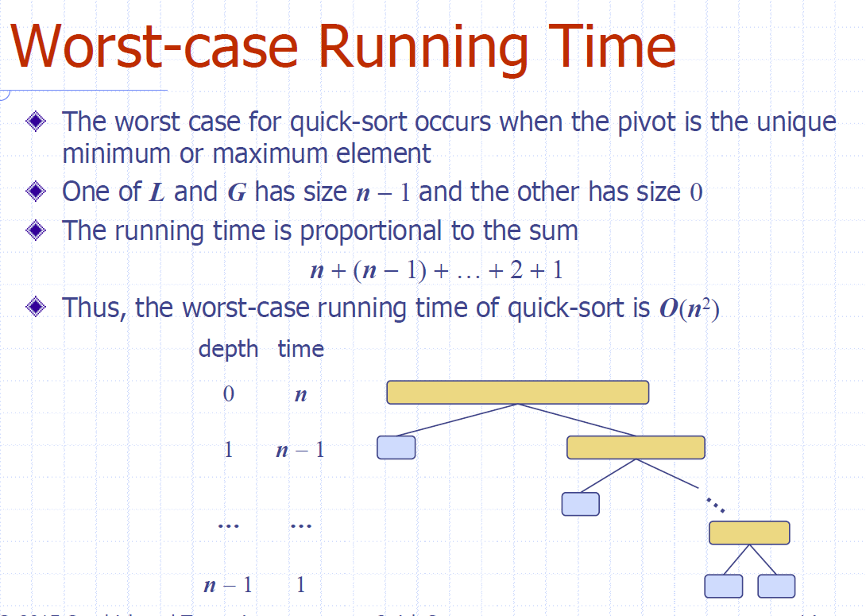

worst case runtime O(n^2) -- When we continue to choose the pivot to be the minimum or maximum element on the subarray.

Outplace：L,E,G

不稳定：有多个等于pivot的值，可能都排到pivot后面去了

- Heap Sort

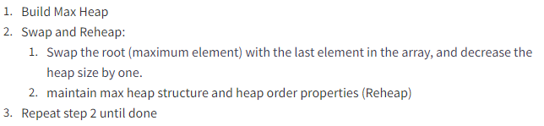

- Bucket Sort

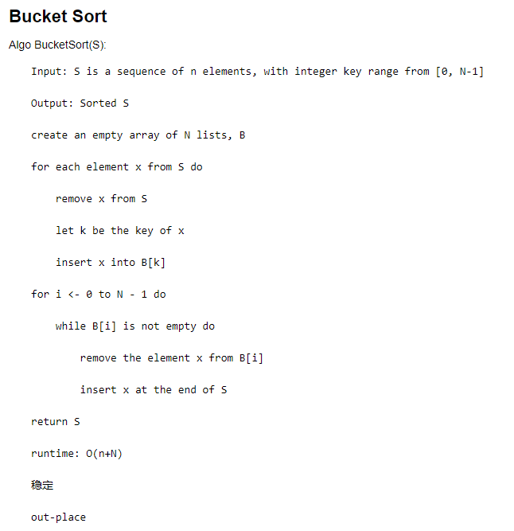

- Radix Sort

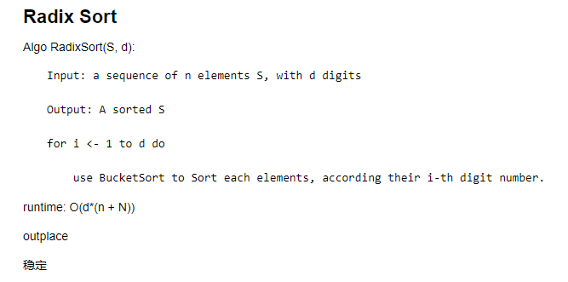

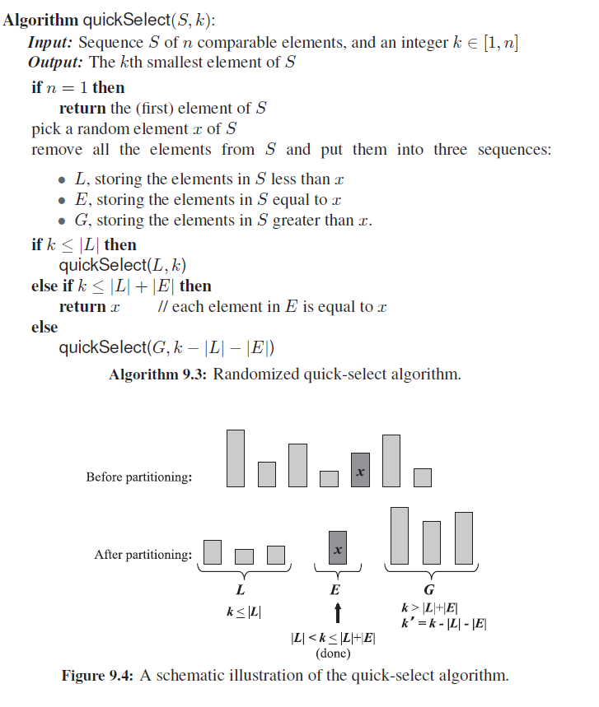

不用MOM的Runtime

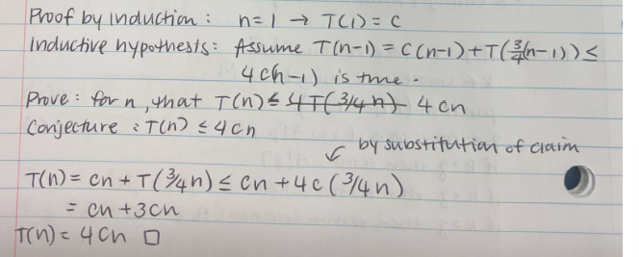

用MOM情况下的quick Selection Runtime



